Exp. 2. Simulation of Density of States of Quantum Well Structure with Various Nanometer Thickness.
Aim: To simulate density of states of quantum well structure with various nano meter thickness
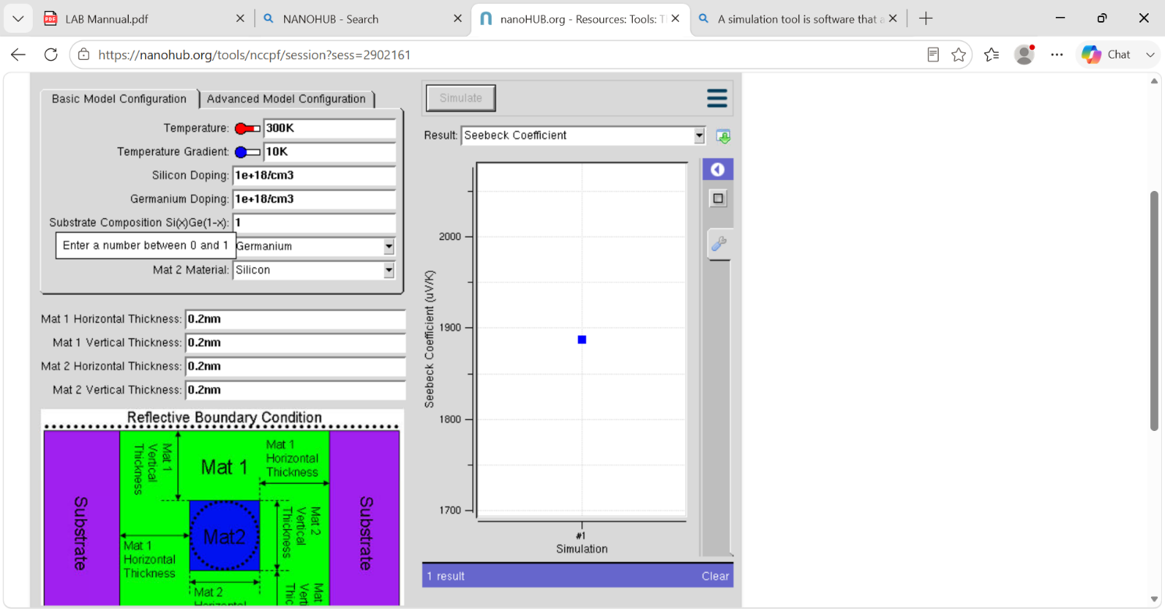
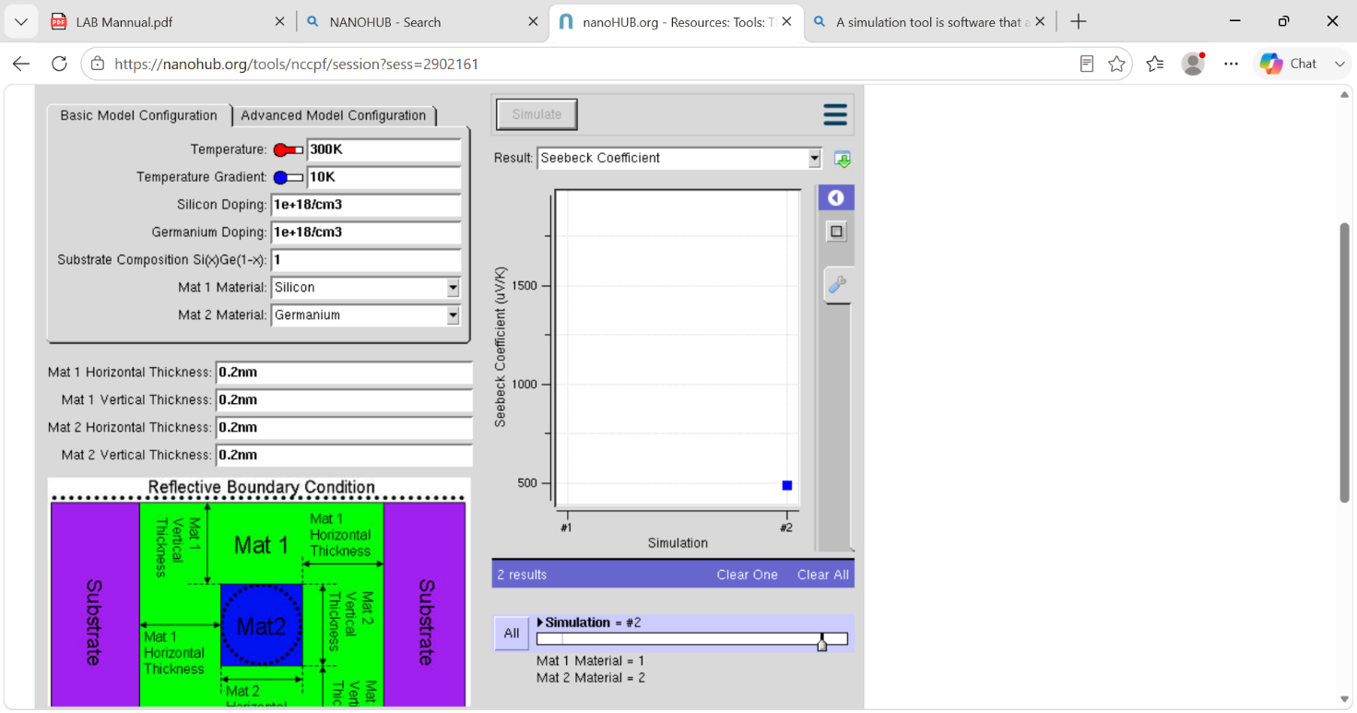
Case Study 1: Simulate the density of states of quantum well of thickness 0.5 nm
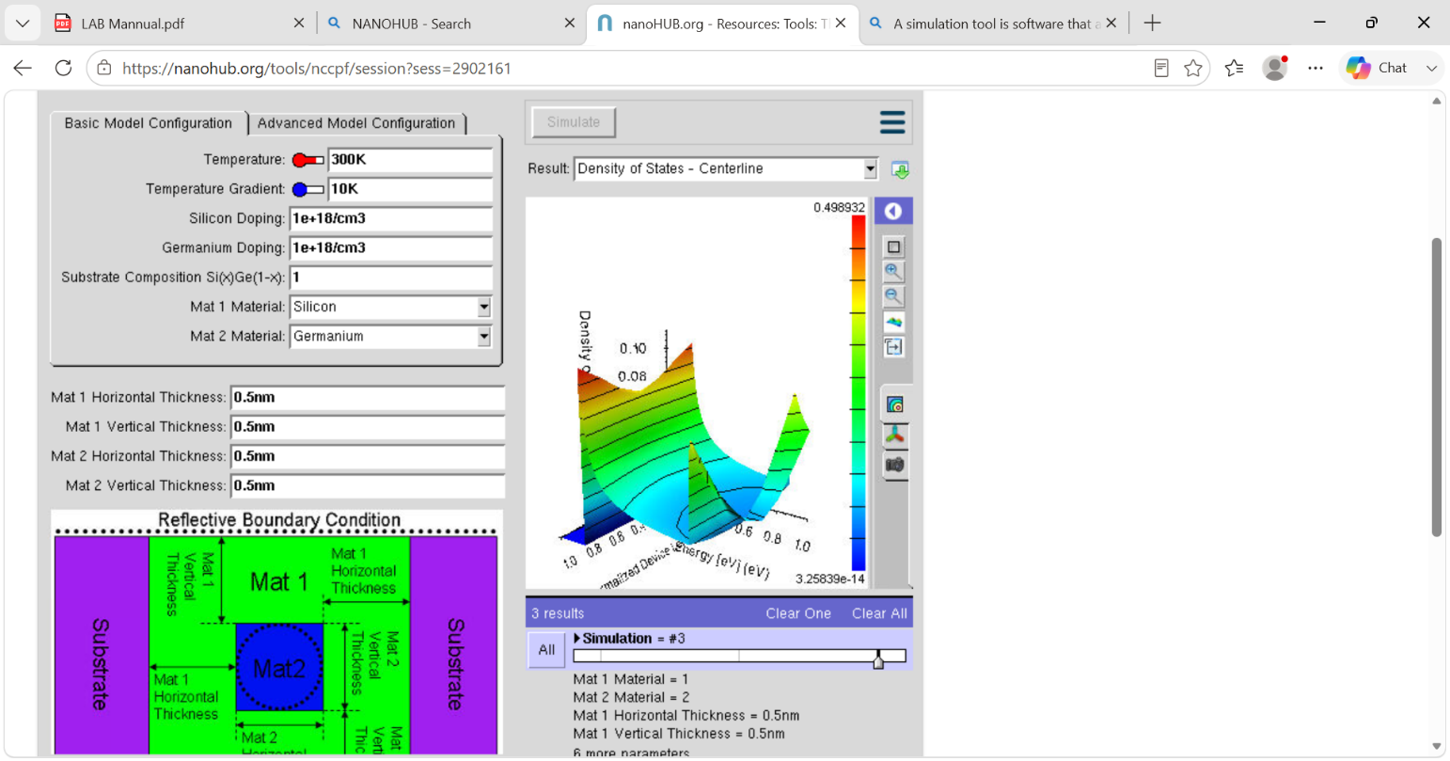
Case Study 2: Simulate the density of states of quantum well of thickness 0.6 nm
